Photos Used:

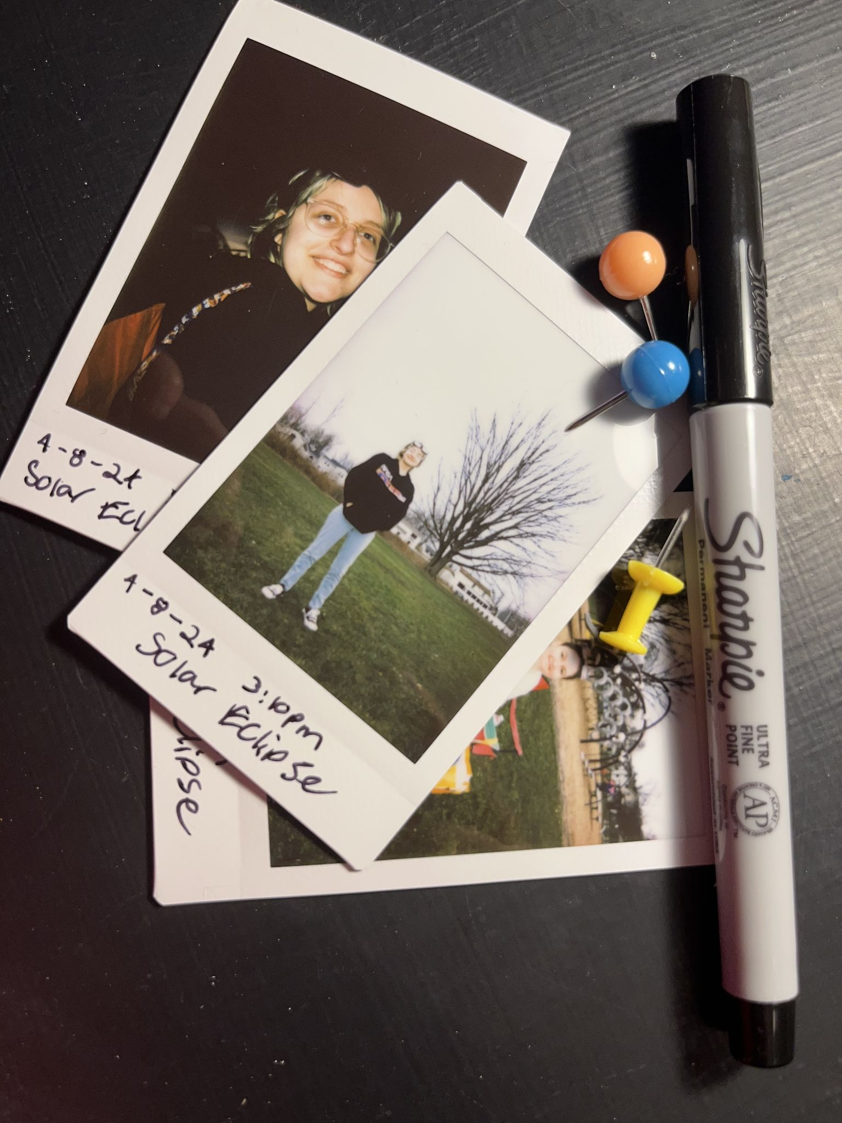

Photo taken by me and my partner

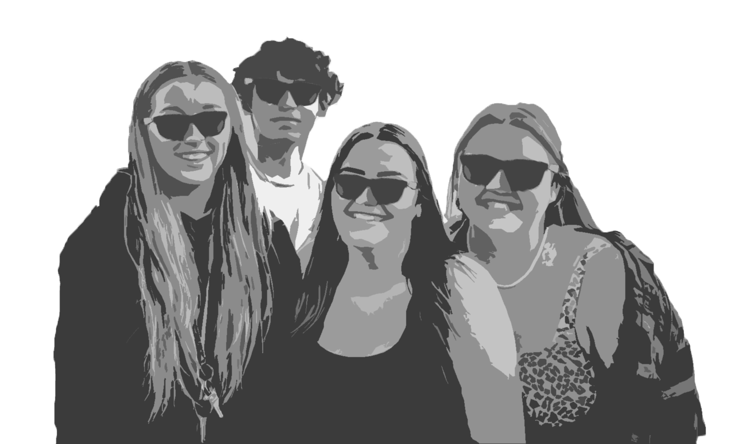

Photo edited by me, original photo:

<https://unsplash.com/photos/photography-of-five-people-near-outdoor-during-daytime-hOF1bWoet_Q>

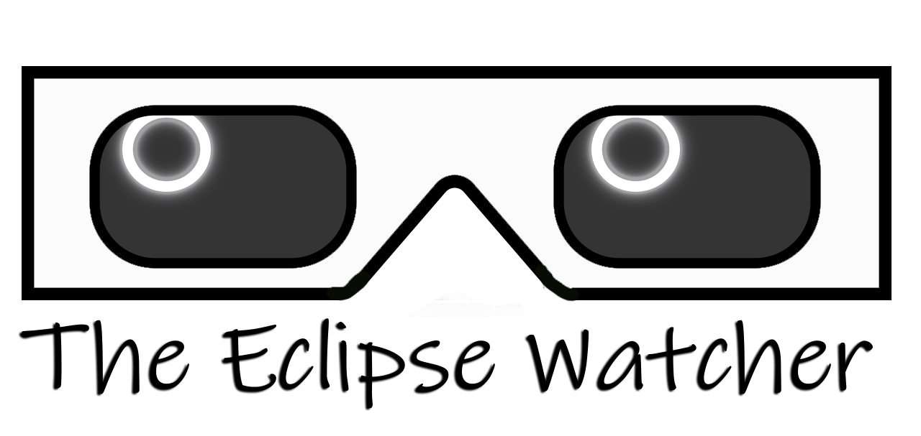

Logo created by me

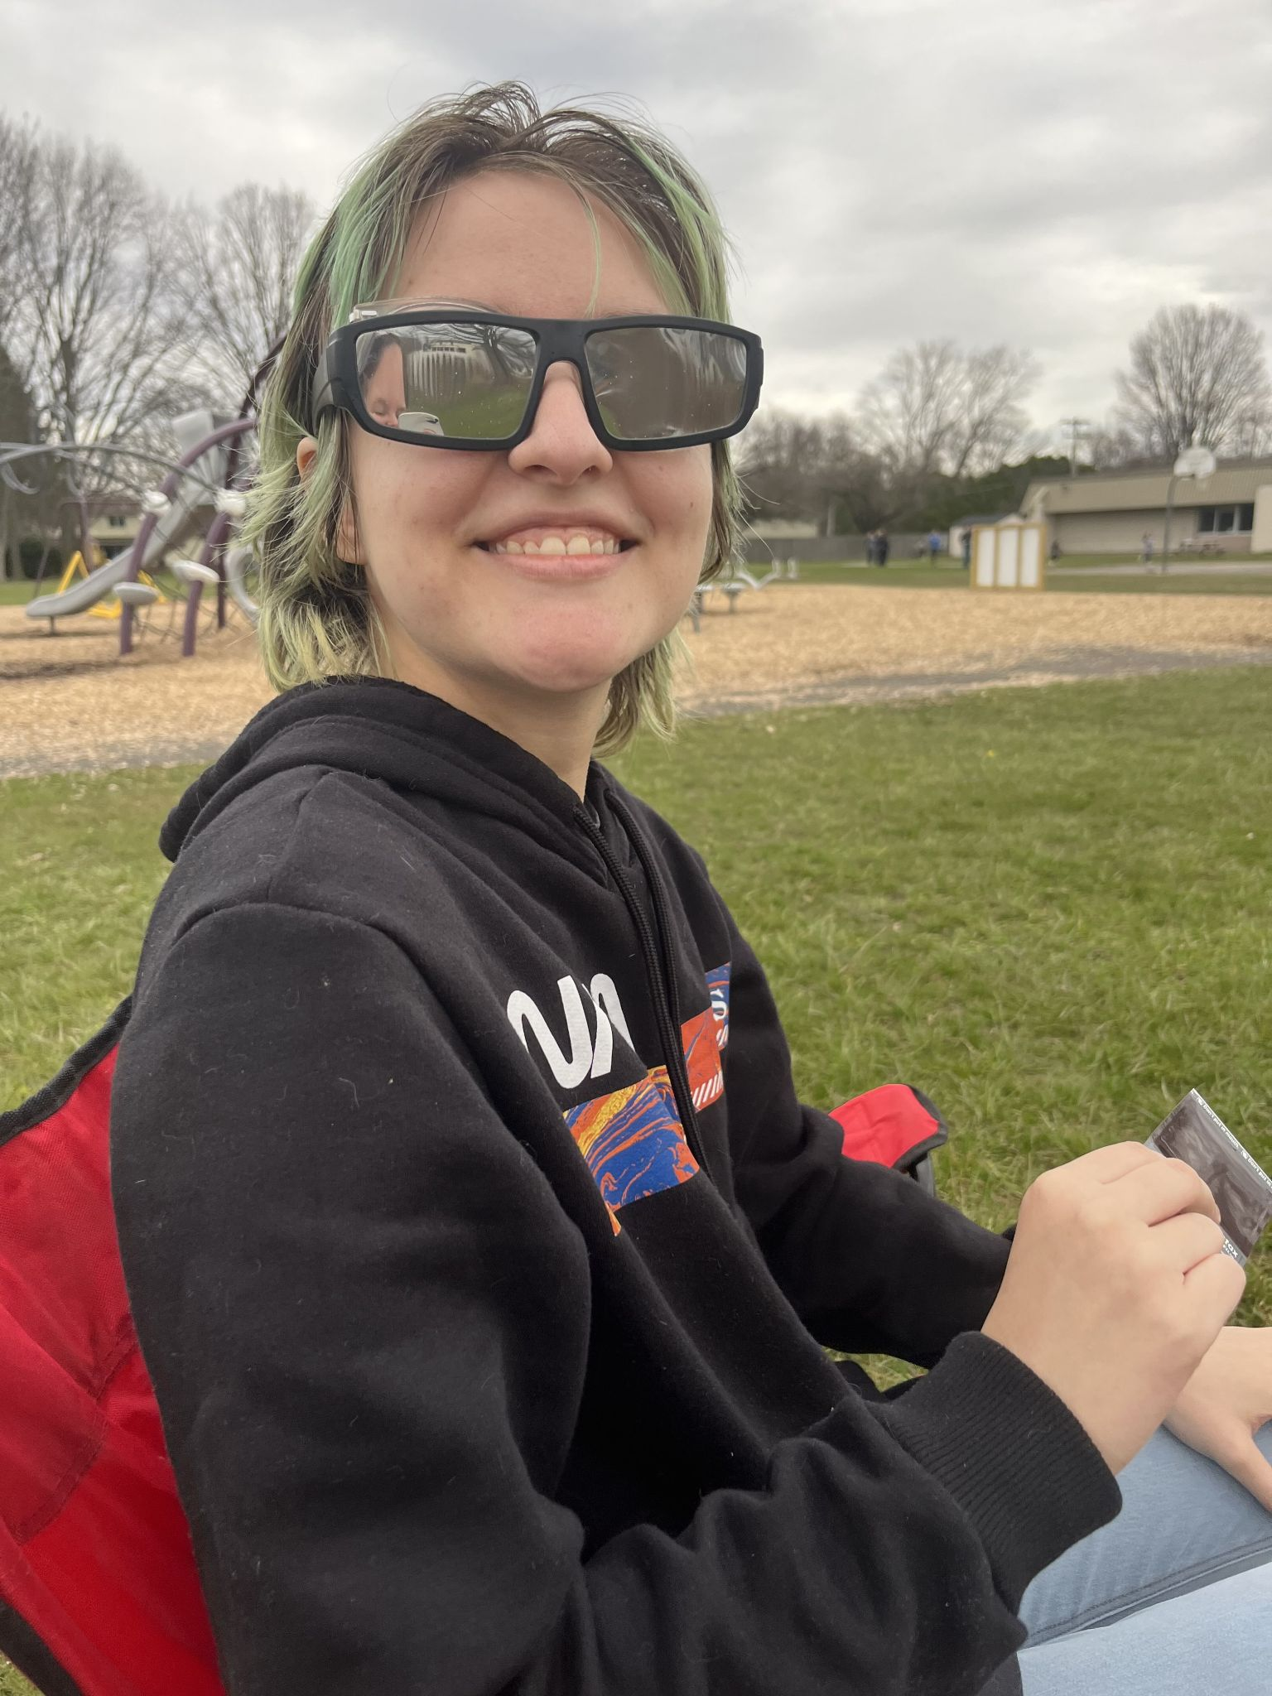

Photo taken by my partner (they allowed me to use it)

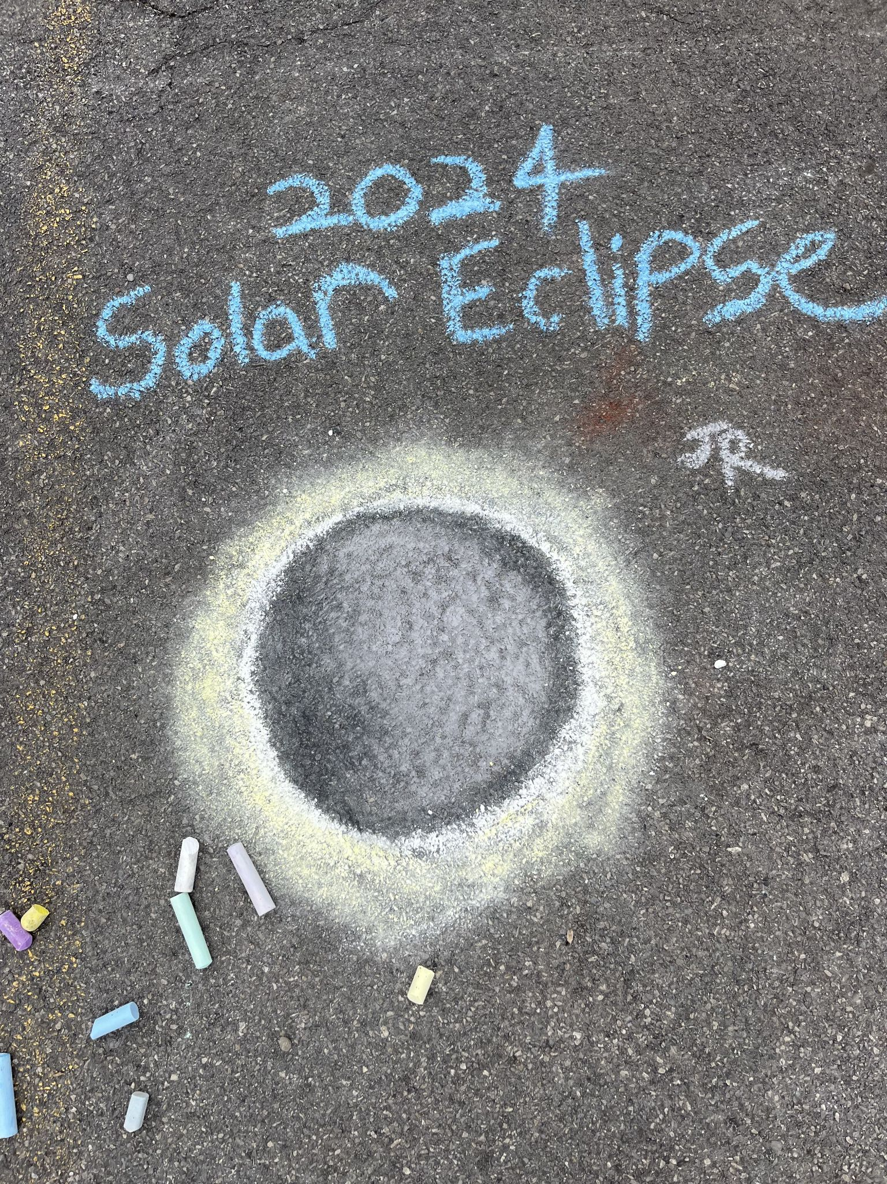

Photo taken by me of my partner’s chalk drawing

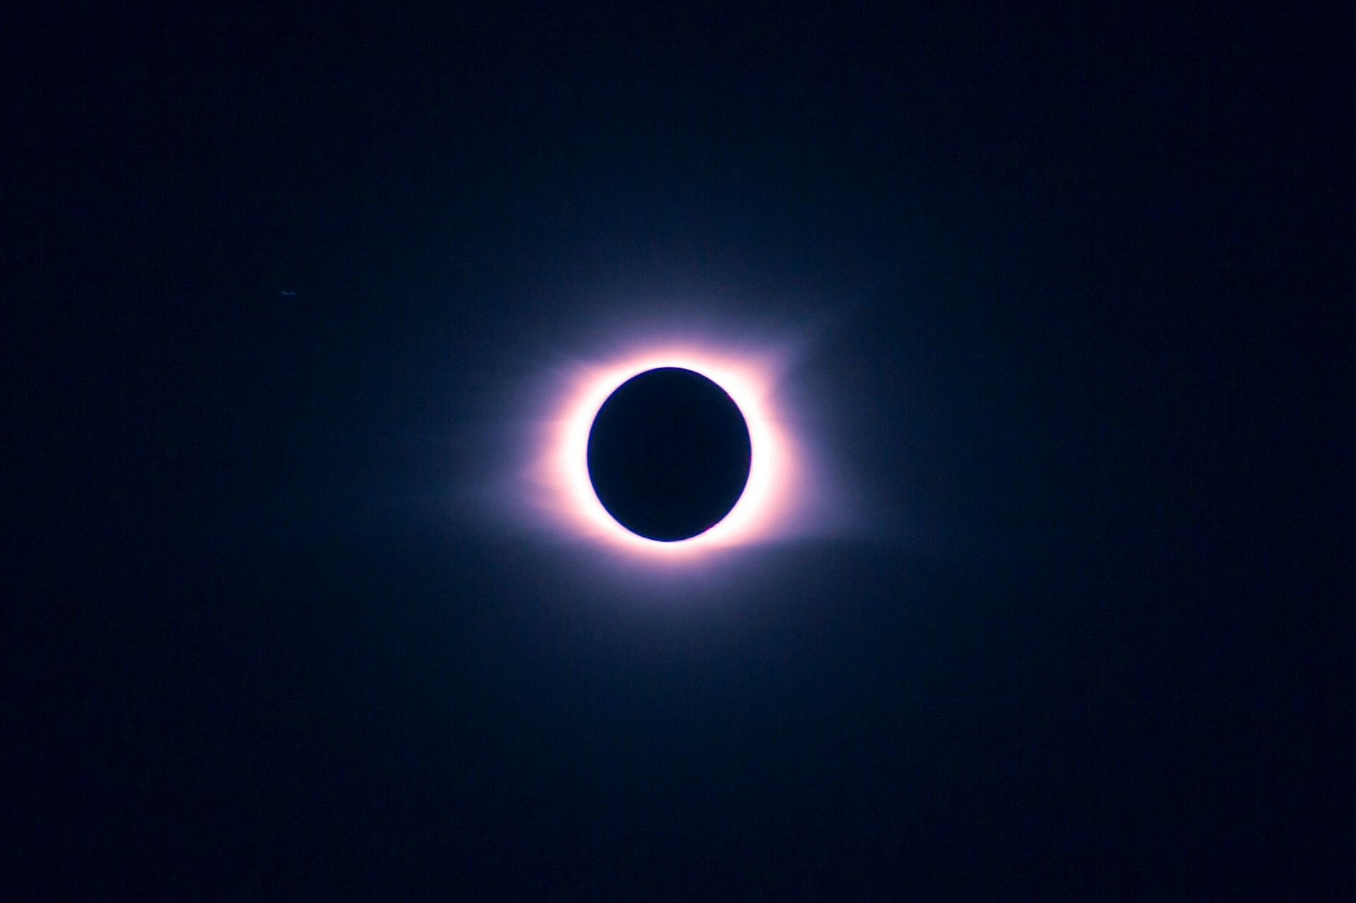

<https://unsplash.com/photos/eclipse-during-night-time-mErBDJdJ2R8>

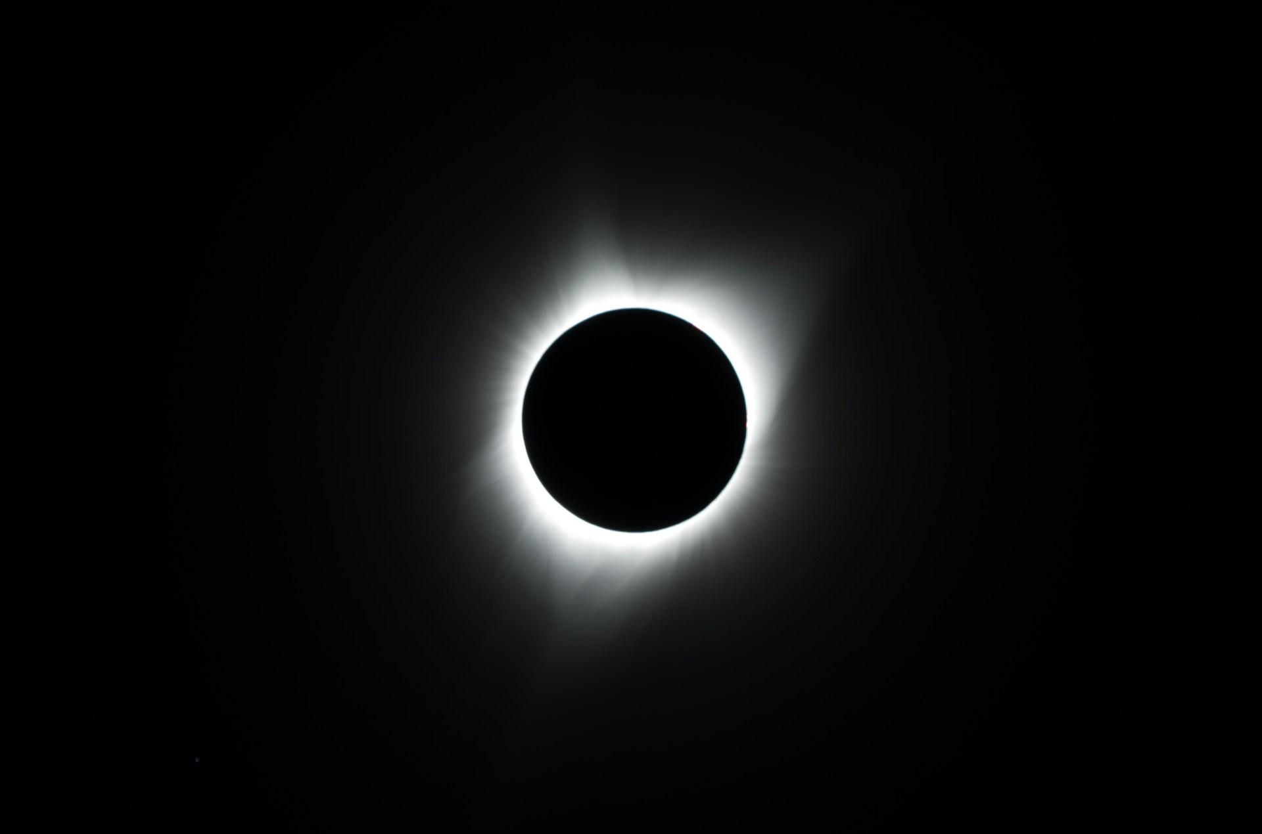

<https://unsplash.com/photos/photo-of-total-solar-eclipse-y07ClgzcVmc>

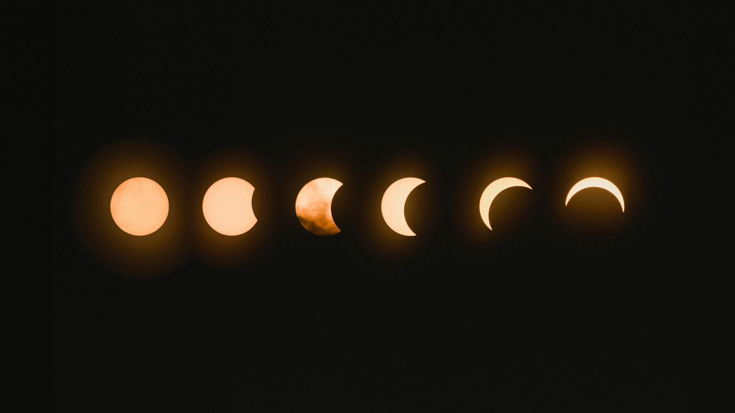

<https://unsplash.com/photos/total-lunar-eclipse-NbgQfUvKFE0>

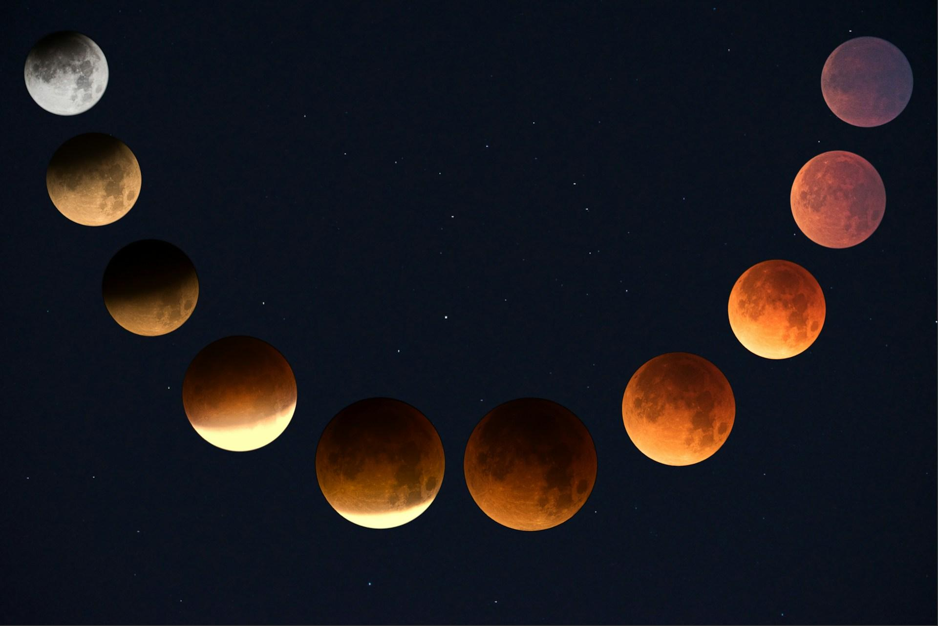

<https://unsplash.com/photos/red-moon-transformation-fjT3Zn2IhIk>